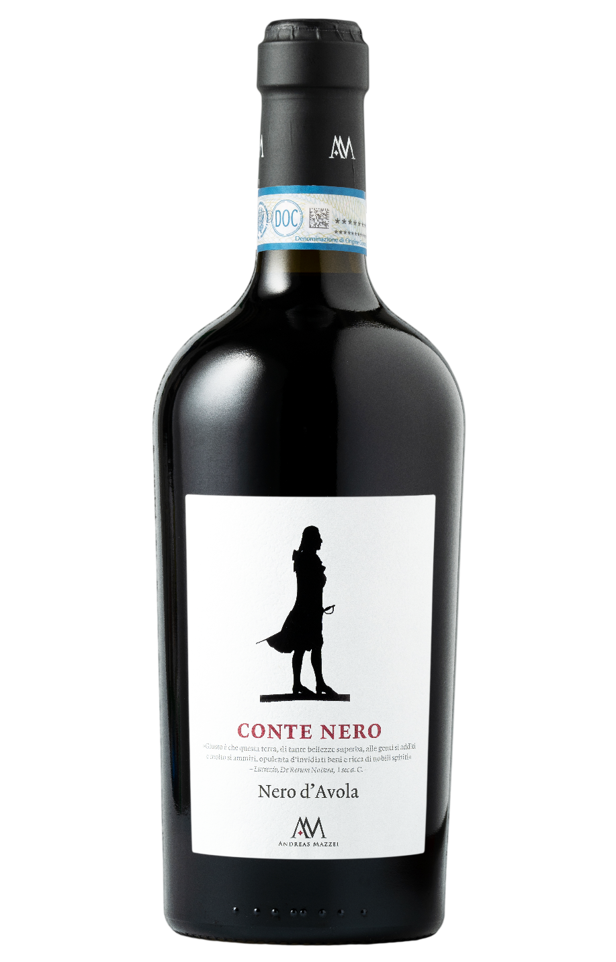
NERO D’AVOLA SICILIA DOP – CONTE NERO
The Nero d'Avola, long considered the undisputed crown prince of Sicilian winemaking, is now part of an operation to further augment its reputation. As of the grape harvest of 2017, it has been definitely awarded "DOP Sicilia" status. This will for sure contribute to highlight the great potential of this variety and provides added value to the product. "Conte Nero" represents the spirit of this wine: intense, deep, impenetrable, almost mystical, but also elegant and aristocratic. A worthy messenger of the land in which it grows.

Grape: Nero d’Avola 100%
Alc. Vol.%: 14,5
Vintage: 2023
Residual sugar g/l: 7,0
Total acidity g/l: 6,4
Region: Sicily
Production zone: Vineyards in Western Sicily
Capacity: 750ml

CHARACTERISTICS

Vinification: Fermentation in steel tanks at a controlled temperature
Aging: 8 months in oak and steel
Yield per ha: 9000kg
Colour: Intense red with violet reflections
Bouquet: Intense aromas of wild berries
Flavour: Elegant, balanced and full bodied, with a smooth and velvety finish

SERVING SUGGESTIONS

Best enjoyed with strong savoury dishes such as grilled meat, roasted meat, game and mature cheeses.
Serving temperature 16-18 °C
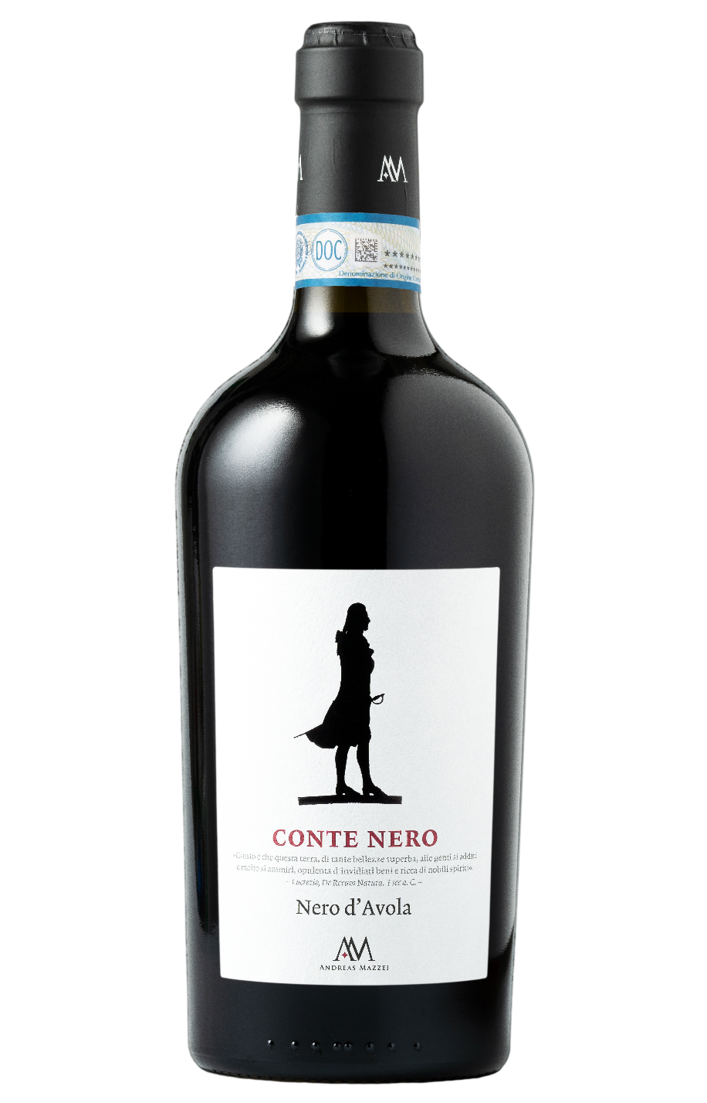
TECHNICAL INFORMATION / PALLETIZING

Size 750ml:
Article Nr. V04001A
GTIN-13 bottle 8017868000792
GTIN-13 carton 8017868000808
Closure Cork
Bottles / carton 6 bottles
Pallet size 80x120cm
Cartons/layer 17
Cartons/pallet 102
Kg/carton 8,4
Kg/pallet 880

Contains sulphites
GMO Free
Revisione 01. 20.10.2026

